**2.Demonstrate how to create the first API request.**

-Add request in collection:

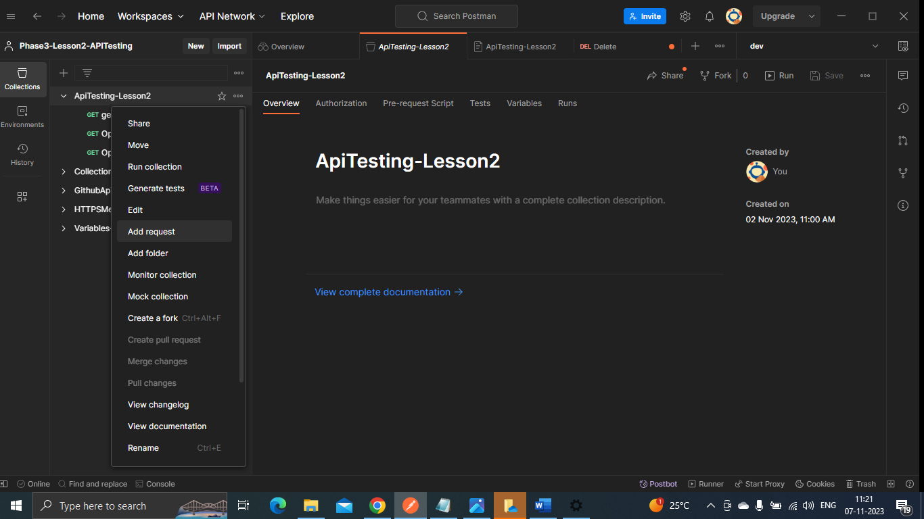

-You can change the request name and add parameters:

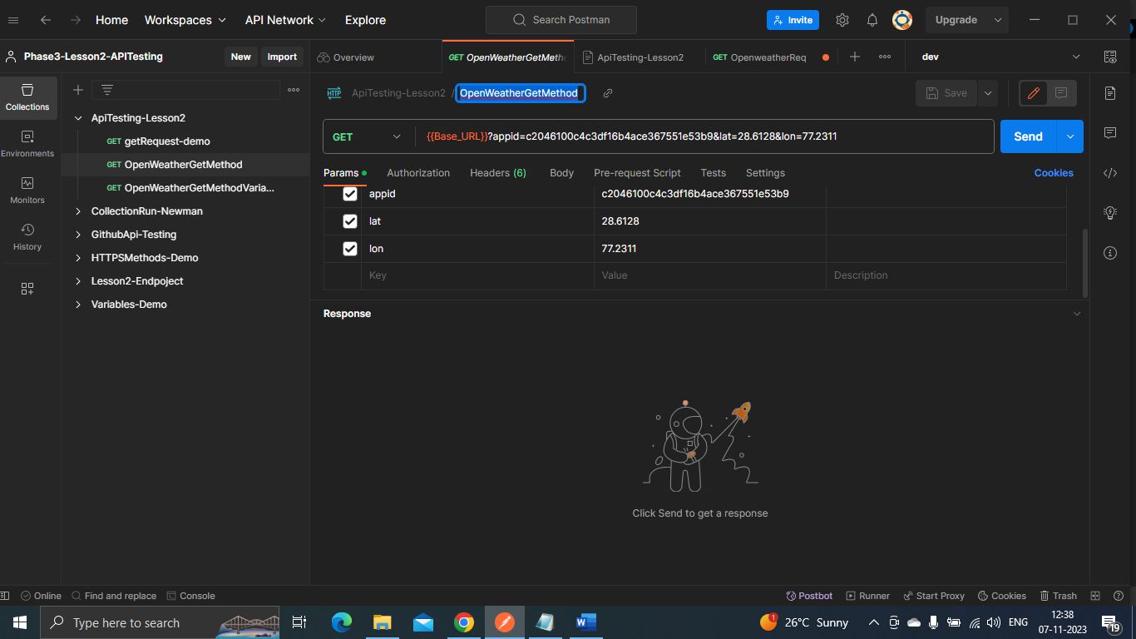

-Save it and click on send the output will be visible:

